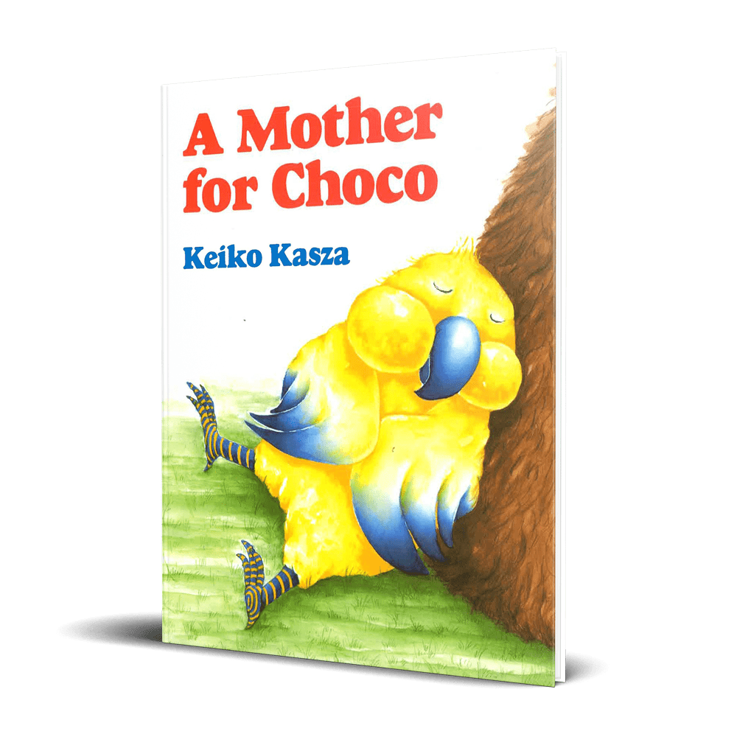

A Mother for Choco
By Keiko Kasza
Family is about love, no matter how different parents and children may be, adopted or not.
In this story, Choco wishes he had a mother, but who could she be? He sets off to find her, asking all kinds of animals, but he doesn’t meet anyone who looks just like him. Mrs. Bear certainly doesn’t look like him, but she starts to do just the things a mommy would do. When she brings him home, he meets her other children—a piglet, a hippo, and an alligator! Choco finds his place in this new kind of family—one that doesn’t look like him but feels just right.
Do you have a blended, multiracial, or unique family dynamic? Choco finds comfort in being loved by someone who doesn’t look like him. Top that off with a well-blended group of siblings, and you have a snapshot of a lot of foster and adoptive families. And this book is just fun!

BUY ON AMAZON →
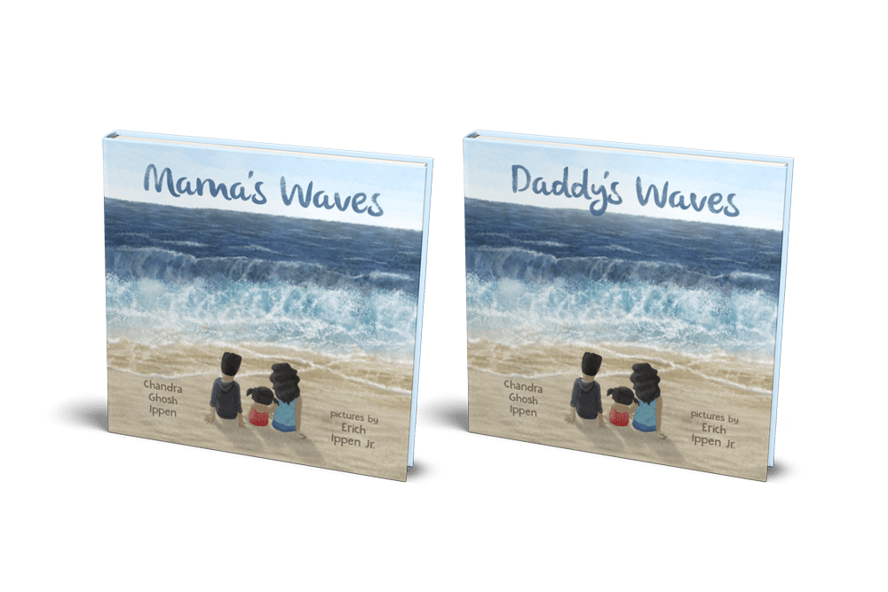

Mama’s Waves & Daddy’s Waves
By Chandra Ghosh Ippen
Ellie’s mom (dad in the parallel version) did not come for their visit, and Ellie is stuck in a cloud of sadness and anger as she tries to understand why. Fortunately, Miss K. and Ellie’s Uncle Finny are there to help her. Using the metaphor of a wave, they help Ellie talk about and understand her mother’s ups and downs, recognize and hold on to loving memories, and know that she is not alone.
In this story that directly addresses a challenge for some children in foster care, the purpose is to open conversation with young children and help them process their confusing emotions.

BUY ON AMAZON →
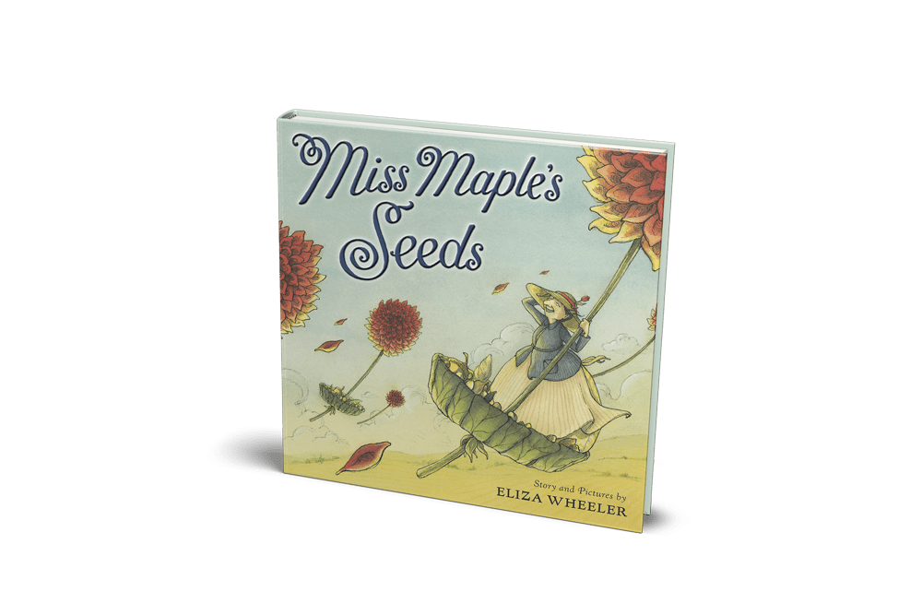

Miss Maple’s Seeds
By Eliza Wheeler
In this story, Miss Maple gathers lost seeds that haven’t yet found a place to sprout. She takes them on field trips to explore places to grow. In her cozy maple tree house, she nurtures them; keeping them safe and warm until it’s time for them to find roots of their own, and grow into the magnificent plants they’re destined to become.

BUY ON AMAZON →
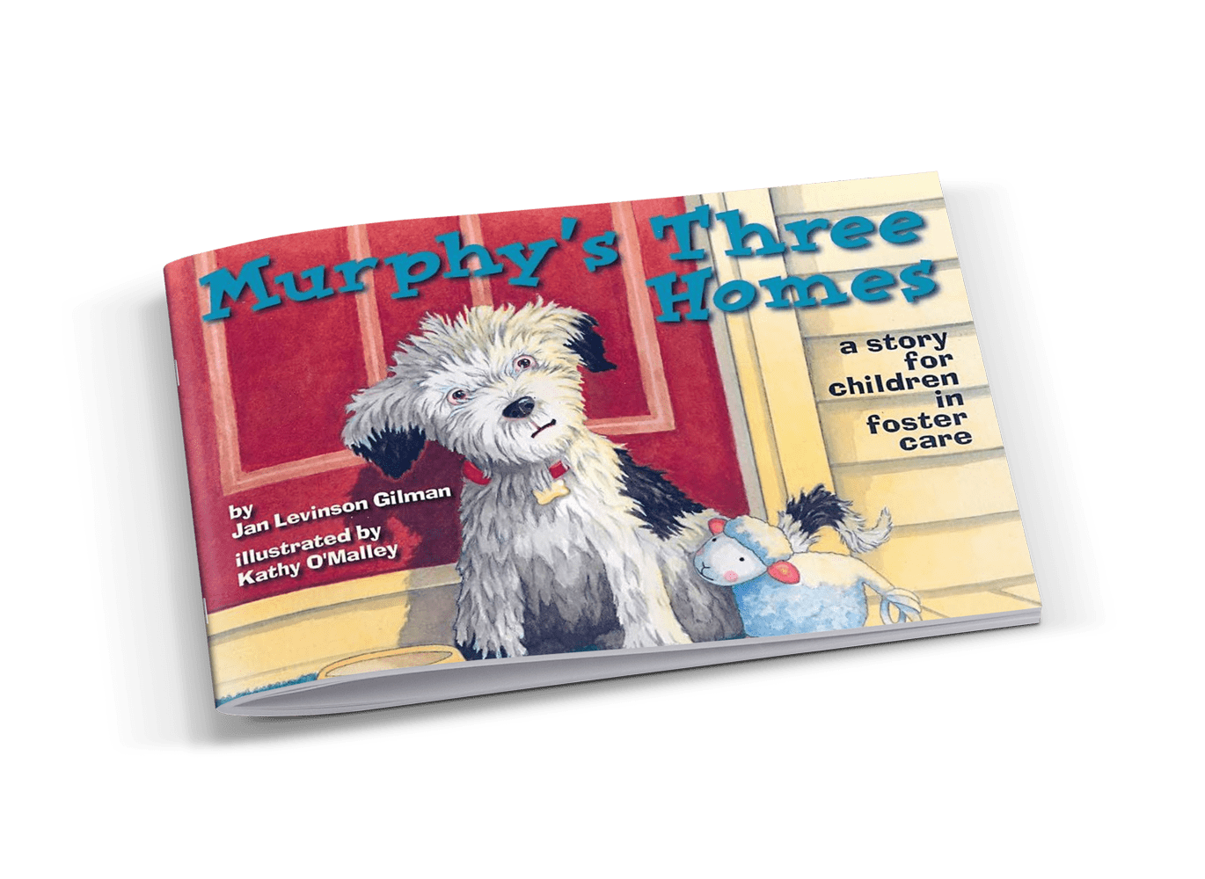

Murphy’s Three Homes: A Story for Children in Foster Care
By Jan Levinson Gilman
If you have an animal lover or a special needs kiddo, consider this one. Murphy, a Tibetan Terrier puppy, is told he is a “good luck dog.” He is cheerful, happy, and loves to play and wag his tail. However, after going through two different homes and an animal shelter, Murphy starts to feel like a “bad luck dog” who nobody wants. He feels like it’s all his fault. Did he do something wrong? He doesn’t feel “good” anymore.
Sometimes, the kids we’re caring for don’t see themselves in other children or characters in stories, but often, animals can be a welcomed relief, an open door to communicating. They empathize with animals and see hurts and pain that otherwise they don’t know how to express. Seeing a dog change homes might be a catalyst to help your child heal and process. If you have a puppy lover in your life that has changed homes a time or two, this is the book for you.

BUY ON AMAZON →
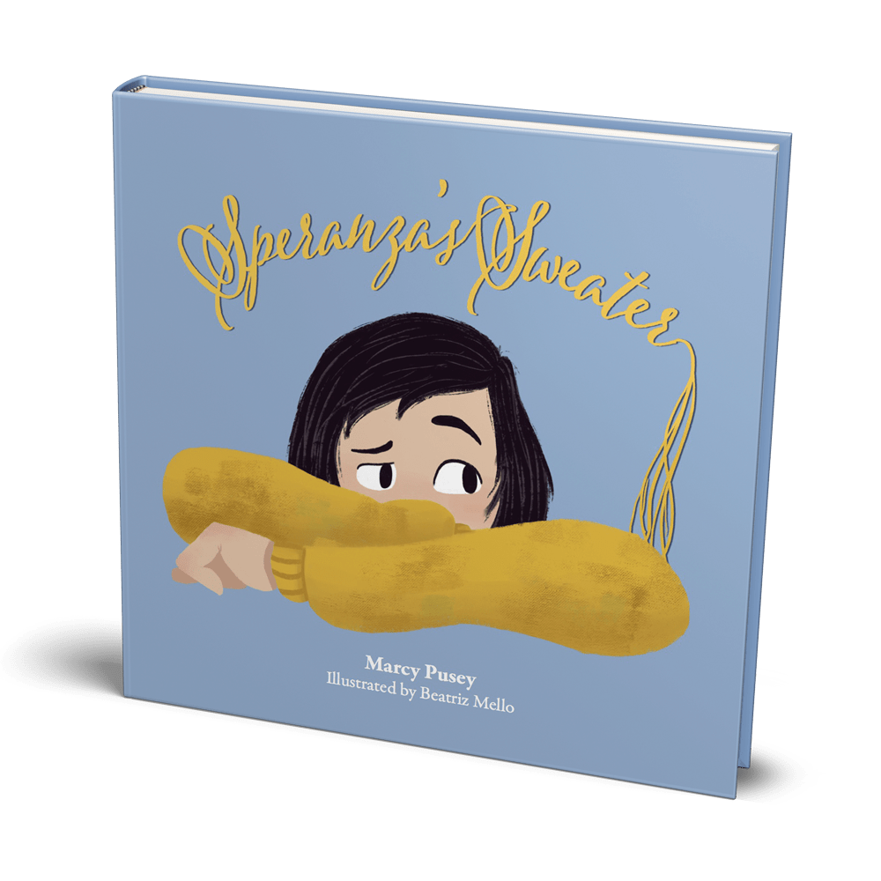

Speranza’s Sweater: A Child’s Journey Through Foster Care and Adoption
By Marcy Pusey
Children deserve a safe place to live and grow and learn. For some of our kids, this means living with foster or adoptive parents. This book chronicles one child’s experience through the foster and adoptive system. Speranza wears her sweater everywhere, hanging onto the last memories of her birth home until it’s threadbare. Like her unraveled sweater, Speranza must weave together a new story, bringing threads from her past and strands from her present into a future of love, family, and the true meaning of home.
As an adoptive mom, I want to hang onto as much information and pieces of my children’s past as I can. This story gives light to the fact that a child’s past is part of their story. Even if the material items disappear, the good memories and experiences can still stay.

BUY ON AMAZON →
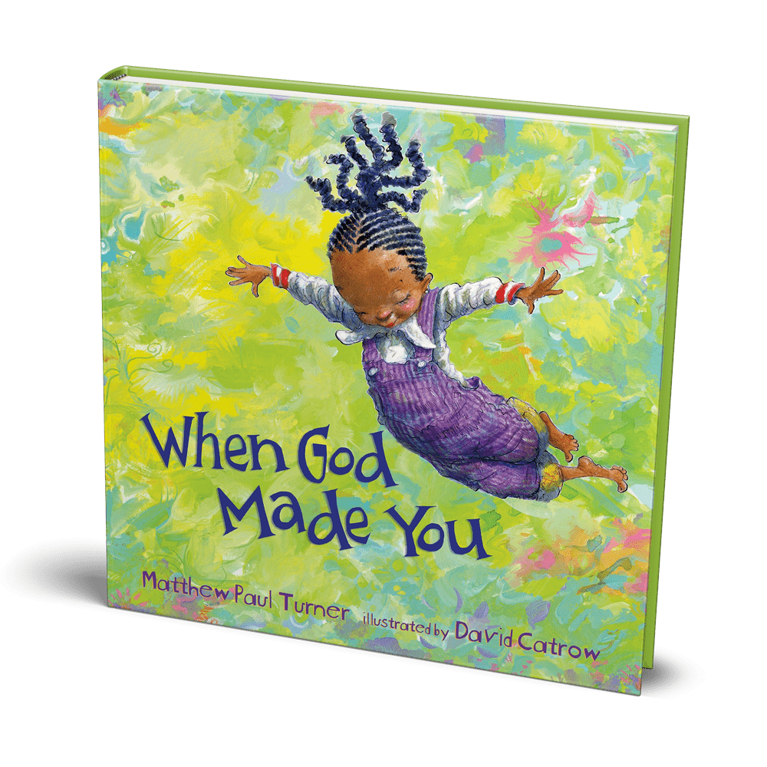

When God Made You
By Matthew Paul Turner
We all crave to know and discover who we are and why we’re here. That can be confusing for someone whose life has been flipped upside down as they enter foster care and are removed from all they’ve ever known. How do I fit in? Why am I here? This book beautifully gives children assurance that they were created with purpose, as they learn about their gifts and how they fit into God’s divine plan.
I love the way it is written and illustrated! It is playful, has charming rhymes, and the pages are filled with so many colors and images that will encourage and engage your child.

BUY ON AMAZON →
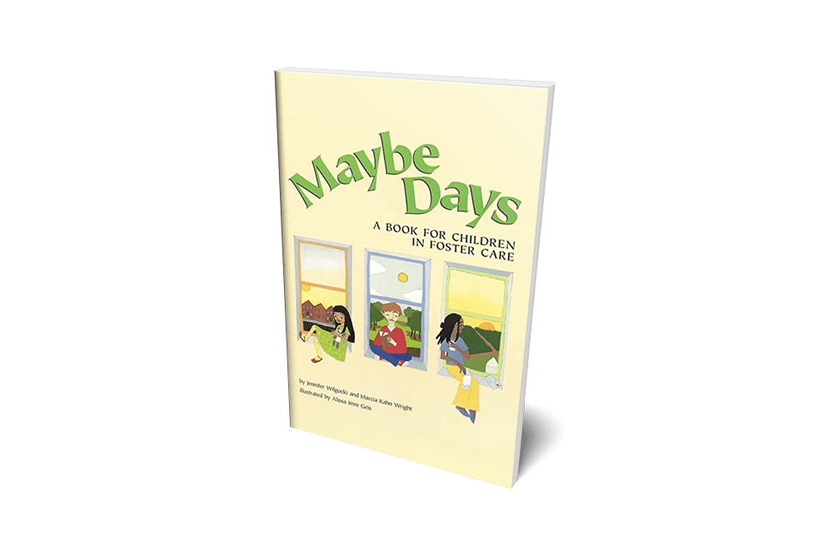

Maybe Days: A Book for Children in Foster Care
By Jennifer Wilgocki
For many children in foster care, the answer to many questions is often maybe. Maybe Days is a straightforward look at the issues of foster care, the questions that children ask, and the feelings that they confront. A primer for children going into foster care, the book also explains in children’s terms the responsibilities of everyone involved – parents, social workers, lawyers, and judges. As for the children themselves, their job is to be a kid – and there’s no maybe about that.

BUY ON AMAZON →
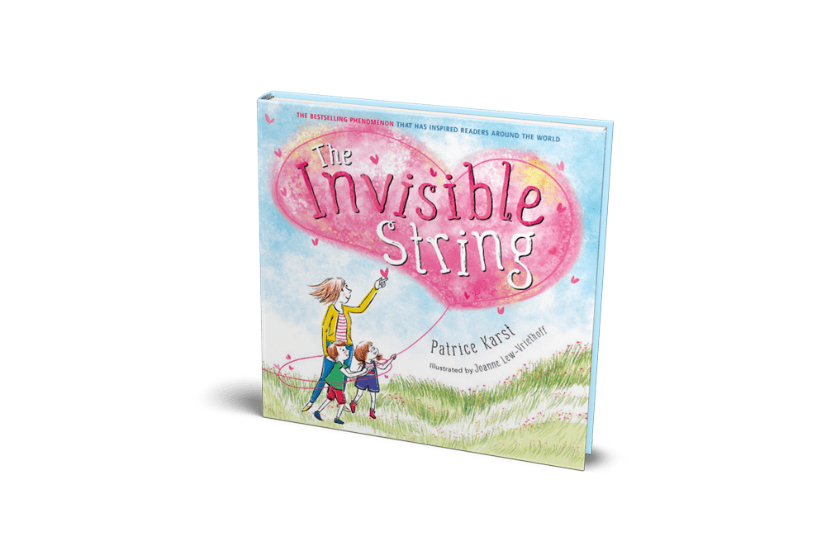

The Invisible String
By Patrice Karst
In this relatable and reassuring contemporary classic, a mother tells her two children that they’re all connected by an invisible string. “That’s impossible!” the children insist, but still they want to know more: “What kind of string?” The answer is the simple truth that binds us all: An Invisible String made of love. Even though you can’t see it with your eyes, you can feel it deep in your heart, and know that you are always connected to the ones you love.
This heartwarming picture book for all ages explores questions about the intangible yet unbreakable connections between us, and opens up deeper conversations about love.

BUY ON AMAZON →
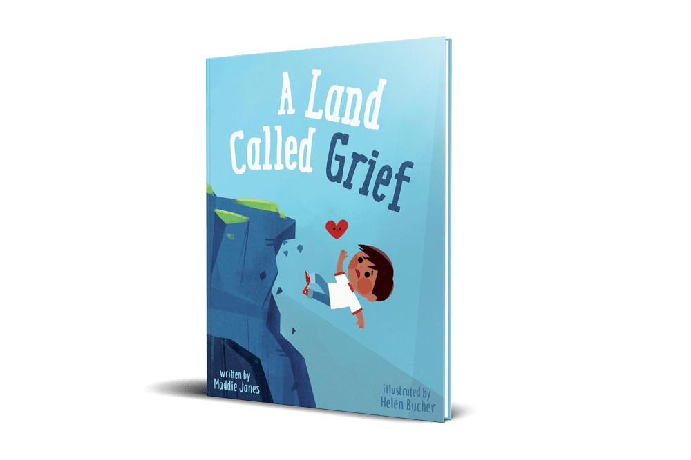

A Land Called Grief
By Patrice Karst
A Land Called Grief is a story that helps little and big kids alike understand the emotions that show up when we navigate through the stages of grief. Although grief can be heavy, this book helps us understand that our grief can be turned into something beautiful. A beauty that can heal. A beauty that can be shared.

BUY ON AMAZON →
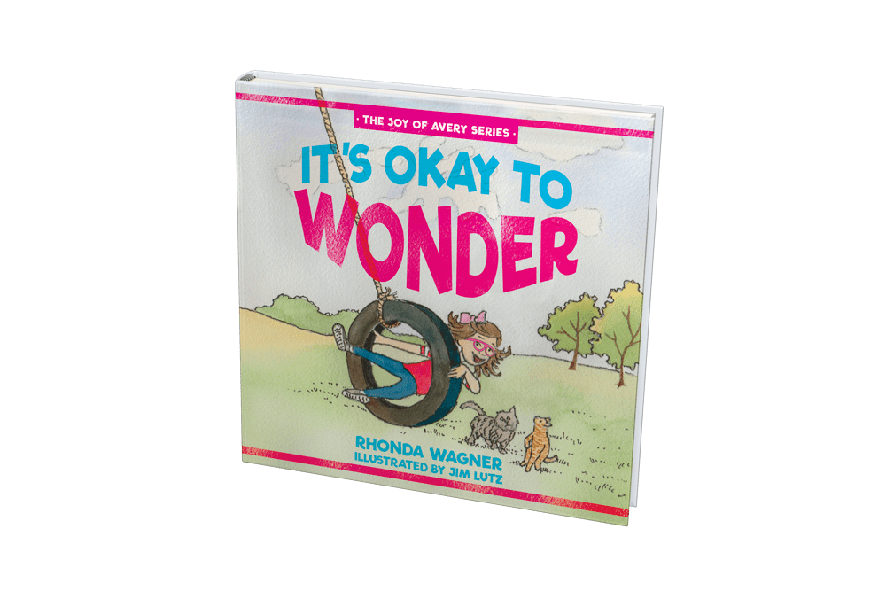

It’s Okay to Wonder
By Rhonda Wagner
(This is a resource primarily to help biological children prepare to welcome foster children into the home.)
It’s Okay to Wonder is a story about Avery, whose parents have decided to become foster parents. While Mom and Dad attend another foster training class, Avery shares with her Nana and Pop about her mixed-up feelings. She and her grandparents learn together what it might be like to become a foster family—that it’s okay to feel two emotions at the same time and that it’s okay to wonder!
The Joy of Avery series offers resources for foster care families and brings the world of foster care to life by exploring Avery’s feelings as her family welcomes foster children into their home. It’s Okay to Wonder is the first book in this faith-based series.

BUY ON AMAZON →
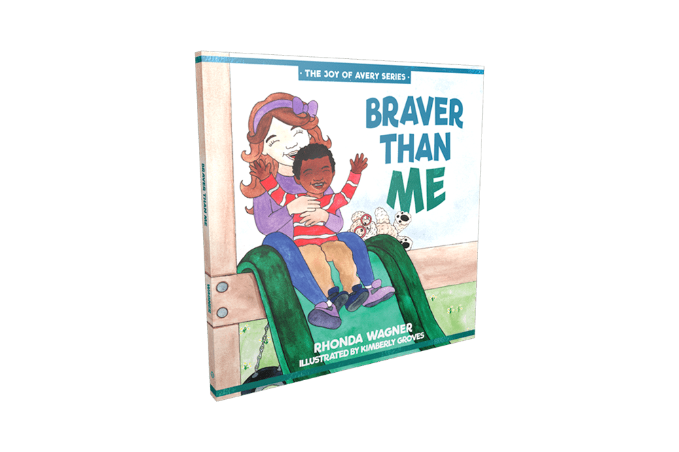

Braver Than Me
By Rhonda Wagner
(This is a resource primarily to help biological children prepare to welcome foster children into the home.)
Braver Than Me is a story about Avery, a loquacious girl whose family welcomes their first foster child into their home. Avery shares with her Mom and Dad about her mixed-up feelings. She and her parents learn together what it is like to be a foster family-that it’s okay to feel two emotions at the same time, especially when reunification takes place. Love, bravery, and empathy fill the pages as Avery realizes her foster sibling is “braver than me.”
The Joy of Avery series offers resources for foster care families, and brings the world of foster care to life by exploring Avery’s feelings as her family welcomes foster children into their home. Braver Than Me is the second book in this faith-based series.

BUY ON AMAZON →
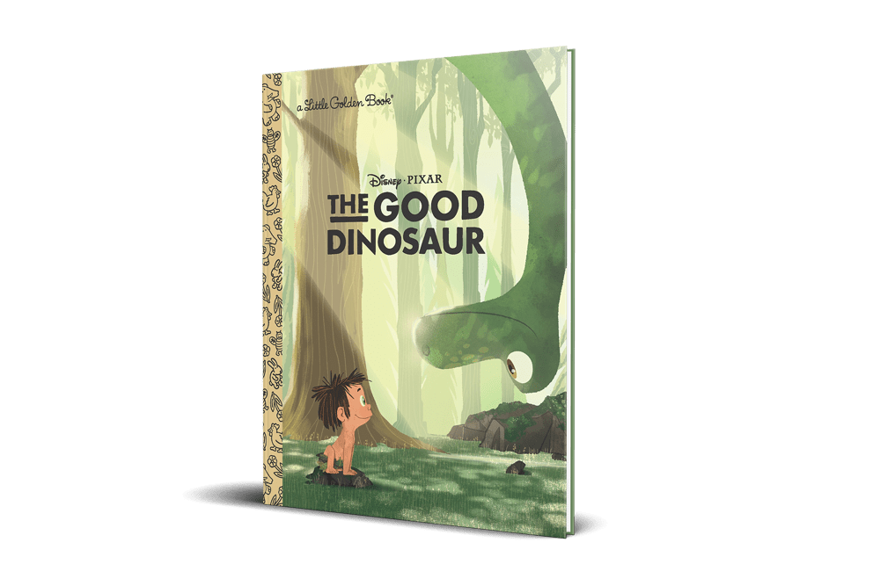

The Good Dinosaur
By Bill Scollon
Based off the Disney/Pixar film, The Good Dinosaur is a humorous and exciting original story about Arlo, a lively Apatosaurus with a big heart. After a traumatic event unsettles Arlo’s family, he sets out on a remarkable journey, gaining an unlikely companion along the way—a human boy.
As they are close to returning home, Arlo learns that his new friend won’t be part of his family forever, and he has to say a hard goodbye. This is a sweet and adventurous story that has the potential to start some special conversations between you and your kids.

BUY ON AMAZON →
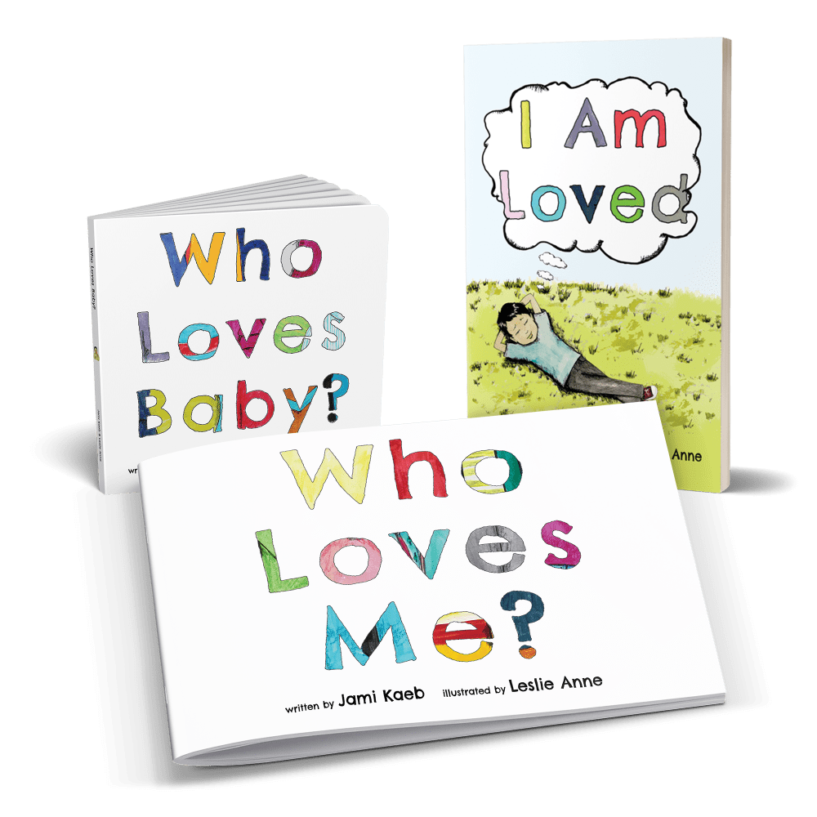

The Who Loves Series
By Jami Kaeb
Ok, I’m a little biased on this one, but I love the Who Loves series! This series is for babies to pre-teens! Children in foster care typically have many individuals moving in and out of their lives. This constant change can lead to the false belief that no one loves them—it doesn’t even seem like anyone will stay with them for the long-term. This series is designed specifically to give children a different perspective on the people they interact with while they are in foster care.
The overarching message to the child is: You are worthy, you are loved, and we are all here for you! I love that these books let you identify and specifically name individuals in your child’s life. Read more about the impact of the Who Loves series for one family…

BUY THE SERIES →

